

press release
(English translation)

RIMINIWELLNESS: INTRODUCING FITNESS FRANCHISING DAY
AN EVENT CONNECTING INDUSTRY ENTREPRENEURS AND INVESTORS

- RiminiWellness 2025 will host the inaugural event, focusing on franchising strategies in the fitness industry, in collaboration with Affilya.
- Friday May 30, exclusive meetings will be held between franchisors, franchisees, and selected investors.
- Networking opportunities to forge new partnerships and drive business growth

Rimini (Italy), 13 March 2025 - A unique opportunity for entrepreneurs and investors in the fitness industry to explore new opportunities for growth and collaboration within the international event that promotes healthy lifestyles. RiminiWellness returns for its 19th edition from May 29 to June 1, 2025, at Rimini Expo Centre and along the Riviera. This year, it introduces the inaugural Fitness Franchising Day, an event organized by Italian Exhibition Group, serving as the ideal platform for those seeking to expand their network, discover innovations, and invest in the rapidly growing market of gym franchising.

FITNESS FRANCHISING DAY: A UNIQUE OPPORTUNITY FOR THE FITNESS INDUSTRY
The inaugural Fitness Franchising Day will take place on Friday May 30, marking a unique event for entrepreneurs in the fitness industry seeking to expand their business opportunities. This event, organised in collaboration with Affilya, one of the most renowned Franchising Communities, will be a must-attend opportunity for franchisors, franchisees, and investors to connect and explore new partnerships. Throughout the day, participants can engage in specialised training sessions, delve into franchising strategies, and engage in discussions with industry experts. As well as conferences and workshops, there will be spaces dedicated to networking, where visitors can meet new partners, discover the latest innovations, and develop strategic collaborations. Whether you're looking to expand your network, acquire new skills, or explore investment opportunities, the Fitness Franchising Day is a must-attend event for intent on growing their business in the fitness industry.

AN EXCLUSIVE EVENT FOR SELECTED PROFESSIONALS
Fitness Franchising Day is an exclusive event for entrepreneurs and professionals, handpicked by Affilya's experts to create a high-level environment where real business opportunities can flourish. The event will be divided into two distinct segments, designed to provide participants with a comprehensive understanding of the dynamics of franchising in the fitness industry. The morning will be filled with conferences and strategic insights, featuring leading speakers who will analyse emerging market trends, share successful models, and provide practical tools for managing and growing a franchise business. Topics include franchising, focusing on opportunities and development strategies, fitness, exploring the evolutions and potential of this market, finance, to understand the fundamental economic levers for business growth, and real estate, a crucial element for brand positioning and expansion. In the afternoon, the focus will shift to networking and collaboration opportunities. Franchisees and potential investors, seeking new business opportunities, along with franchisors interested in expanding their network, will have the chance to connect directly through targeted meetings. These exchanges will provide a concrete opportunity to establish strategic connections, explore valuable synergies, and lay the foundation for new collaborations. A unique opportunity to transform ideas into concrete projects and build successful relationships in the industry.

ABOUT RIMINIWELLNESS 2025
Date: 29 May – 1 June 2025; event type: international expo; organizer: Italian Exhibition Group S.p.A.; recurrence: annual; edition: 19th; open to: general public and professional operators; info: www.riminiwellness.com

PRESS CONTACT ITALIAN EXHIBITION GROUP
head of corporate communication & media relation: Elisabetta Vitali
press office manager: Marco Forcellini, Pier Francesco Bellini | press office coordinator: Luca Paganin | international press office coordinator: Silvia Giorgi | press office specialist: Mirko Malgieri; Nicoletta Evangelisti | media@iegexpo.it

MEDIA AGENCY RIMINIWELLNESS
Naper Multimedia| Zoe Perna | T. +39 02 97699600 | zoe.perna@napermultimedia.it | staff@napermultimedia.it

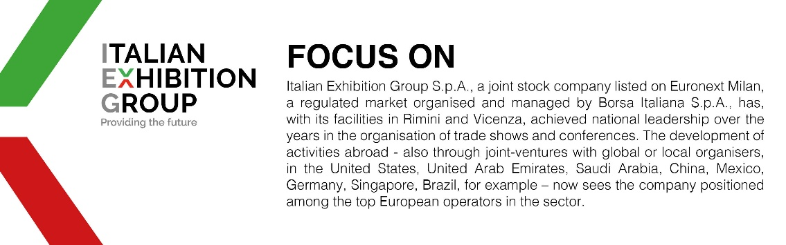

This press release contains forecast elements and estimates that reflect the management’s current opinions (“forward-looking statements”), particularly regarding future management performance, realization of investments, cash flow trends and the evolution of the financial structure. For their very nature, forward-looking statements have a component of risk and uncertainty, as they depend on the occurrence of future events. The effective results may differ (even significantly) from those announced, due to numerous factors, including, only by way of example: food service market and tourist flow trends in Italy, gold and jewellery market trends, green economy market trends; the evolution of raw material prices; general macroeconomic conditions; geopolitical factors and evolutions in the legislative framework. Moreover, the information contained in this release does not claim to be complete, and has not been verified by independent third parties. Forecasts, estimates and objectives contained herein are based on the information available to the Company as at the date of this release.

